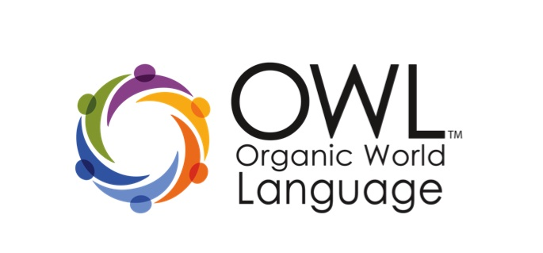
OWL 1 Workshop: Foundations & Application
March 6th -7th, 2014- Devens, MA
Registration Form

Personal Information

Name ____________________________________________________________________Date________________

Email _________________________________________________ Phone number: ______________________
School or Association _______________________________________________________________________

Language ________________________________________ Age / Grade Level: ______________________

How did you hear about OWL?______________________________________________________________

Workshop Details

The cost is for this two-day workshop is $300. The workshop will be held at Francis Parker School in Devens, MA from 8:30AM -3:30PM on March 6th and 7th, 2014. Printed resources and PDU Certificates will be provided.

Registration and Payment

Please submit this registration form via email at:  info@organicworldlanguage.com | Full payment must be received prior to the workshop.  - Credit card: Visa, MasterCard & American Express  - Checks: Payable to OWL.

Cancellation Policy:
§ Three weeks prior to the first day of workshop: 75% refund
§ One week or less prior to the first day of workshop: 25% refund
§ Less than one week before workshop begins: no refund

Credit cards: Credit card purchases will be charged an extra 2.4% for processing fees

Credit card: __________________________________________ Credit card #: ________________________

Expiration date: _______________________________________________ Code: _______________________

Business Office – please do not write

Date received: ________________________________ Date entered: _______________________________

Not paid: __________________ Paid: _______________________ Check #: __________________________

Contact Information:

Darcy Rogers or Annie Tyner
info@organicworldlanguage.com

