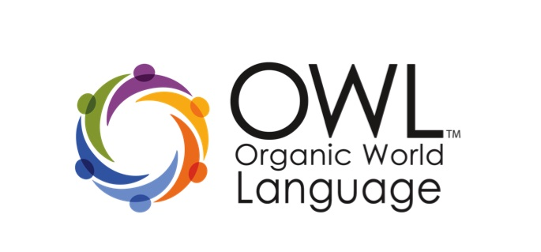
OWL 1 Workshop: Foundations
Wallingford, CT - March 4th, 2014
Registration Form

Personal Information

Name ____________________________________________________________________Date________________

Email _________________________________________________ Phone number: ______________________
School or Association _______________________________________________________________________

Language ________________________________________ Age / Grade Level: ______________________

How did you hear about OWL?______________________________________________________________

Workshop Details

The cost is for this workshop is $175. The workshop will be held in Wallingford, CT from 9:00AM -4:00PM on Tuesday, March 4th. Printed resources and PDU Certificates will be provided.

Registration and Payment

Please submit this registration form via email at:  info@organicworldlanguage.com | Full payment must be received prior to the workshop.  - Credit card: Visa, MasterCard & American Express  - Checks: Payable to OWL.

Cancellation Policy:
§ Three weeks prior to the first day of workshop: 75% refund
§ One week or less prior to the first day of workshop: 25% refund
§ Less than one week before workshop begins: no refund

Credit cards: Credit card purchases will be charged an extra 2.4% for processing fees

Credit card: __________________________________________ Credit card #: ________________________

Expiration date: _______________________________________________ Code: _______________________

Business Office – Please do not write

Date received: ________________________________ Date entered: _______________________________

Not paid: __________________ Paid: _______________________ Check #: __________________________

Contact Information:

Darcy Rogers or Annie Tyner
info@organicworldlanguage.com

